This agenda is posted in accordance with the Ralph M. Brown Act, CA GC §.5, et seq. at the following locations: French Camp Post Office, Fire Station 11-1, and frenchcampfire.com. This meeting may be recorded. Members of the Board of Directors may ask questions about, discuss, consider, approve, and/or act on any listed agenda item and any related variable unless specifically otherwise indicated (such as under Public Forum/Public Comments and Correspondence). Members of the Board may vote to go into Executive Session(s), which will not be open to the public, on any agenda items for legal advice with the Fire District Attorney on the matter(s) set forth in the Agenda.

During the Public Comments portion of the meeting, speakers will be limited to five (5) minutes, and this will constitute the public’s right to comment. Without intending to limit anyone’s rights, speakers are encouraged to keep their remarks concise and polite. Speakers will arise and identify themselves for the record and give their name and address. Pursuant to the California Government Code, items not on the agenda cannot be acted upon at this time but may be added to future meeting agendas. Public comment is encouraged, but it is important that everyone demonstrates the appropriate decorum, courtesy, and respect during the meeting.

In compliance with the American Disability Act (ADA) Pursuant to 42 USC Sec.12132 & California Government Code 54953.2, individuals who require specific accommodations to access, attend, or participate in this meeting, please contact the Fire Chief at least two business days prior to the meeting to ensure that the District is available to assist you. Please call (209)932-8628 or email admin@frcfire.com

- CALL TO ORDER / ROLL CALL
  - Pledge of Allegiance
  - Approval of September Regular Board Meeting Minutes
  - Approval of September Special Board Meeting Minutes
  - Approval of October Agenda
- PUBLIC COMMENTS
- CHIEF’S REPORT
  - Incidents, Response Times, and Training
  - Apparatus & Equipment
- COMMITTEE REPORTS
  - Budget & Finance
- OLD BUSINESS - NONE
- NEW BUSINESS / CONSENT / ACTION ITEMS
  - September Payables and Mountain House Billing
  - Approve Bills Over Payables Limits
  - Approve Resolution 24-25-06: Department of Forestry and Fire Protection Agreement # 7GF24038 for services from the date of the Agreement to June 30, 2025, under the Volunteer Fire Capacity Program of the Cooperative Forestry Assistance Act of 1978.
  - Appointment in lieu of election for Sonny Daniel Rego and Rosemire Zanini by the County Board of Supervisors, in accordance with Elections Code Section 10515.
  - Appointment of Gloria Murphy by the Board of Directors, in accordance with CA Government Code Section 1780(d)(1).
- CHIEF COMMENTS
  - Personnel Updates
  - Department Activities
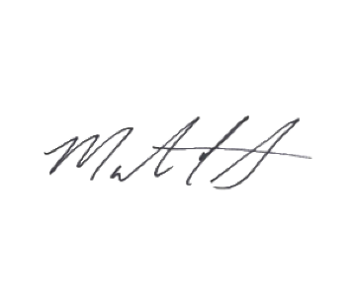
- BOARD COMMENTS
- ADJOURNMENT

Marty Cornilsen, Fire Chief
Submitted October 9, 2024

